SEVENHAMPTON PARISH COUNCIL
ANNUAL MEETING OF THE COUNCIL
TO BE HELD AT 7PM ON 16TH MAY 2022
IN THE VILLAGE HALL
Welcome and introductions – by the present Chairman
Election of Chairman – signing of acceptance of office papers
Election of Vice-Chairman – signing of acceptance of office papers
Attendance recorded as Parish Councillors (anticipated as Lynne Jackson, Harry Boyd, Emma Lanfear, Mathew Cain, Bill Jenkin, Joanna Ruddock and Gordon Day. County Councillor Paul Hodgkinson & District Councillor Robin Hughes)
Apologies received recorded,
Declaration of Interest for matters on the agenda to be invited-
Public Participation will be invited (for a period of 5 minutes or as determined by Chair of meeting)
Report received from County Councillor Hodgkinson (may be carried forward to Parish Assembly which immediately follows this meeting)
Report received from District Councillor Hughes (may be carried forward to Parish Assembly which immediately follows this meeting)
Minutes of the previous Parish Council Meeting held on 5th April 2022 to be approved
Council to review delegation to Clerk of authority to make submission of comments on planning matters where no meeting of the Council is able to be held
Council to consider if changes are required to standing orders or financial regulations
Council to consider if any changes are required to the asset register
Council to review representation on outside organisations such as No Crash group
Council to review any lead Councillor roles
Council to consider if any changes are required to insurance policy for the coming year
Council to consider if any changes are required to banking mandate
Council to consider if any changes are required to its Complaints, Freedom of Information or Data protection policies procedure
Council to approve its independent internal auditor
Council to confirm it wishes to renew its subscriptions and/or contracts
Council confirm process for defibrillator updates to be submitted –
Council to approve the financial reports and payment list as attached
Council to approve its AGAR completion and delegate to the Chair of Council to sign the appropriate forms
Council to consider update on Jubilee celebrations
Council to agree that its meeting schedule shall remain as 3rd Thursday of May, July, September, November, January, March commencing at 7.30pm
Meeting to be closed

SEVENHAMPTON PARISH COUNCIL

Draft Minutes for meeting held on
5th April 2022
At 7.30pm in the Village Hall Brockhampton

Welcome and introductions
Attendance recorded as Parish Councillors Lynne Jackson, Harry Boyd, Bill Jenkin, Mathew Cain, Joanna Ruddock and Gordon Day, 22 members of the public . District Councillor Hughes did not attend
Apologies received recorded from Parish Councillor Emma Lanfear, and County Councillor Hodgkinson
Declaration of interests on matters on the agenda were invited- Cllrs Jenkin /Boyd declared an interest in the recording studio as close neighbours
Public session for up to 15 minutes (at the Chairs’ discretion). Members of the public were invited to speak to and ask questions of the Council for any matters on the agenda,
Yelllow Shark application- planning agent spoke on behalf of the application
Pre-application advice has been sought from CDC. The Landscape and Conservation Officers have given advice on the siting of the application and the effect on the conversation area. questions were then invited from the public/Councillors
Questions were asked regarding
- The dimensions- Answered as the documents meet the legal requirements and are also given with narrative detail in the documents. There is also visualisation images. Further details were given from the documents
- The applicants gave an insight for the design decisions taken including
consideration has been given to alternative designs and impact on the commercial use of the different designs
- Traffic and deliveries to site – it was felt that 4 parking spaces are adequate for the clients likely to be visiting the site
- Turning circles and manoeuvring space allowing vehicles to exit and return to the highway in forward gear
- Why a “3-bedroom residential accommodation” is required. It was stated that it is a more attractive and creative space and a rural location is desirable. It would also be more commercially viability
- Resident spoke in support of the applicant
- Sound will not be transferred outside of the building. Their business experience of 20 years has not had one environmental/sound complaint. A full noise assessment has been done and the recording studio will be totally contained
The environmental sound reports are on the planning portal
- General comment on the protection of the characteristics of the Village, to sustain a dynamic based economy, in support the recording studio but object strongly to the 2nd application on the agenda
- How will it create jobs and increased economy in the village? It was stated that it will generate economy in the wider local area. The studio will occasionally employ cleaner, cooks, accountants
Replacement dwelling
- Pre-application process not followed according to the planning portal
- No requirement for environmental impact report to be submitted noted from the planning portal
- Ecology, landscape and environmental impact study not submitted as information stated that there are no ecology or environmental impact on the site
- Local resident spoke that it is possible to design new architectural styles which does not harm the area but this one has +300% increase in volume, footprint and is not compatible with the Cotswold design code
Barn and Tawny Owls, Red Kites and dragonfly insect etc populations will be impacted by the design.
Noting it is within the AONB area
- Height of the house will impact on neighbours
- Aesthetically the designs are confused and without context. There are no impact visualisations
- Preservation and character of the building is very important but will this open the way for other modern designs
- It is just outside the Conservation area but it will have big impact on the area
- The amount of light pollution was of concern as it will a beacon on the hill
- There does not seem to be any planning notices posted in the vicinity or statutory notice on the website
- Access to the site is on very narrow roads and the impact during the construction period
- The new development will be about 1m higher than the present dwelling
- The height of the wall is being increased which in not characteristic of local walls
Public session ended at 20.16

Council approved the minutes from the Council meeting held on 21st March 2022
Council noted defibrillator update – installed in Sevenhampton Phone Box. Monthly reports to be submitted by Clerk, nominated local person to send information via email
Council approved payment of Good Neighbour insurance premium £179.87
Council noted update on Jubilee events advice from Insurance Company
The parish council will be covered for public liability for the Jubilee event for up to 500 attendees. If this number is estimated to be more, additional cover will be needed.
If there will be a bouncy castle additional liability cover may be needed if the council are supervising the use themselves.
A risk assessment will need to be completed
Planning matters discussed and responses agreed
22/00754/FUL Construction of recording studio with ancillary accommodation at
Land Parcel Easting 403637 Northing 222282 – consultation expires 19th April 2022
Parish Council agreed to support noting the height concerns
and traffic
22/00941/FUL Replacement dwelling with erection of garage & outbuilding at
Wychwood Brockhampton consultation expires 15th April

Parish Council agreed to object with inappropriate design, lack of detail in the planning application and other concerns heard during the public session being part of the Parish Council’s submission
Clerk advised on the legality of the submitting the Council’s comments which should be agreed by Council at the meeting. However the Clerk does have delegated authority (already given ) to submit comments on behalf of Council.
It was agreed that a draft of Council submission will be submitted to the Clerk who will then submit under delegated authority
Clerk will contact District Councillor to highlight the concerns of the Parish Council and the public
Date of next meeting May 16th 2022 – AGM 7pm Parish Assembly 8pm
Any other information for sharing
none
Close of meeting 20.26

Cash book y/e 31/3/22
payee | date | CHQ NO | TRANSACTION | CURRENT BALANCE
 |  |  |  | 13231.75
ico | 07/04/2021 | dd | -35.00 | 13196.75
cots district council | 27/04/2021 | receipt | 63.07 | 13259.82
cots district council | 27/04/2021 | receipt | 6120.00 | 19379.82
b holder salary | 26/04/2021 | so | -224.30 | 19155.52
discount domaine | 17/05/2021 | 743 | -15.59 | 19139.93
zurich car scheme | 17/05/2021 | 744 | -179.87 | 18960.06
gaptc | 17/05/2021 | 745 | -85.99 | 18874.07
mm lewis /3048 | 17/05/2021 | 746 | -95.00 | 18779.07
hmrc a,m,j | 17/05/2021 | 747 | -168.60 | 18610.47
b holder expenses | 17/05/2021 | 748 | -67.35 | 18543.12
community first | 31/05/2021 | 750 | -205.68 | 18337.44
mr lewis/3053 | 10/06/2021 | 751 | -95.00 | 18242.44
m lewis / | 19/07/2021 | 752 | -95.00 | 18147.44
hmrc a,m,j | 19/07/2021 | 753 | -177.80 | 17969.64
b holder expenses | 19/07/2021 | 754 | -71.80 | 17897.84
m lewis / | 01/09/2021 | 755 | -95.00 | 17802.84
b holder expenses | 20/09/2021 | 756 | -101.80 | 17701.04
lost in post hmrc£ 280 | 20/09/2021 | 758 |  | 17701.04
b holder salary | 26/05/2021 | so | -224.30 | 17476.74
b holder salary | 26/06/2021 | so | -224.30 | 17252.44
b holder salary | 26/07/2021 | so | -224.30 | 17028.14
b holder salary | 26/08/2021 | so | -224.30 | 16803.84
clerks direct- lost in post | 20/11/2021 | 59 | 0.00 | 16803.84
leeds building society | 20/09/2021 | 758 | -1000.00 | 15803.84
PATA | 20/11/2021 | 60 | -46.50 | 15757.34
m lewis /sept | 30/09/2021 | 759 | -95.00 | 15662.34
cancelled | 03/11/2021 | 758 | 0.00 | 15662.34
l jackson defib maintenance | 03/11/2021 | 761 | -394.00 | 15268.34
good neighbour scheme | 31/10/2021 | receipt | 66.44 | 15334.78
b holder salary | 26/09/2021 | so | -224.30 | 15110.48
b holder salary | 26/10/2021 | so | -256.65 | 14853.83
cots district council | 23/09/2021 | receipt | 2040.00 | 16893.83
PATA 20/21 | 17/11/2021 | 764 | -95.00 | 16798.83
b holder expenses | 11/11/2021 | 762 | -14.64 | 16784.19
hmrc oct nov dec | 14/11/2021 | 763 | -177.80 | 16606.39
disc domaine | 14/11/2021 | 62 | -119.99 | 16486.40
hmrc j,a,s,o.n w/off | 09/11/2021 | 61 | 0.00 | 16486.40
m lewis | 17/11/2021 | 63 | -95.00 | 16391.40
commcorp | 17/11/2021 | 64 | -12.00 | 16379.40
b holder expenses | 17/01/2022 | 57 | -25.44 | 16353.96
bt phone box | 12/01/2021 | 65 | -1.00 | 16352.96
m lewis | 12/01/2021 | 66 | -95.00 | 16257.96
clerks direct | 12/01/2021 | 67 | -12.00 | 16245.96
b holder salary/wfh | 26/11/2021 | so | -256.65 | 15989.31
b holder salary/wfh | 26/12/2021 | so | -256.65 | 15732.66
rhodes village hall | 17/01/2022 | 68 | -52.50 | 15680.16
community heartbeat | 17/01/2022 | 69 | -2550.00 | 13130.16
wayleave | 21/01/2022 |  | 21.08 | 13151.24
The village show donation | 31/01/2022 |  | 1500.00 | 14651.24
b holder salary/wfh | 31/01/2022 | so | -256.65 | 14394.59
b holder salay/wfh | 28/02/2022 | so | -256.65 | 14137.94
b holder expenses | 10/03/2021 | 70 | -23.94 | 14114.00
raymex | 10/03/2021 | 71 | -50.00 | 14064.00
b holder backpay | 10./3/22 | 72 | -47.80 | 14016.20
pata | 10/03/2022 | 73 | -49.60 | 13966.60
litter picker emma pillow | 10/03/2022 | 74 | -40.00 | 13926.60
hmrc | 31/03/2022 | 75 | -179.60 | 13747.00
pata payroll | 22/03/2022 | 76 | -28.85 | 13718.15
b holder salary/wfh | 28/03/2022 | so | -256.65 | 13461.50

Bank reconciliation to 31/3/22
BANK RECONCILATION
OPENING BANK BALANCE | 01/04/2021 |  |  | 13231.75
EXPENDITURE FOR PERIOD |  |  | 8014.40
INCOME FOR PERIOD |  |  | 8244.15
NET EXPENDITURE |  |  |  | -229.75
BANK BALANCE AS ABOVE |  |  |  | 13461.50
BAL PER S/M | 31/03/2022 |  |  | 16086.85
LESS U/P CHEQUES
hmrc lost in post £280 | w/off
 | PATA | 60 | 46.50
 | PATA | 76 | 28.85
 | Banked 4/4/22 | 69 | 2550.00
 |  |  |  | 2625.35
31/03/2022 |  |  |  | 13461.50 | 0.00
reconciled balance
Leeds BS Deposit account | 12980.05 | deposit | 1000.00 | c/bal | 13980.05*
 | Total bank balance |  |  |  | £27441.55

*Waiting statement due May 22
Raised query with PATA re unpresented cheques

Payment list for May 22 meeting
M J Lewis – 5 months grass cutting £475.00 at £95 cut (April, May, June, July, August)
Tree protectors £125.14
HMRC (April, May June ) £175.80
B Holder expenses and £4.00 underpayment of salary £26.80

Budget against actual at 31/3/22
budget to date | BUDGET | ACUTAL YEAR TO DATE | BALANCE AVAILABLE TO SPEND
PRECEPT | 8160 | 8160
CIL | 0 | 63
bank interest deposit account | 0
inter account trans | 0
wayleave | 21 |  | 0
VAT to be reclaimed | 0 | 0
other receipts |  | 0
INCOME | 8181 | 8223 | 0
employment costs | 3825 | 3519 | 306
BT box | 100 | 51 | 49
grit bins | 100 | 0 | 100
hire of venue | 75 | 53 | 23
admin/use of home | 482 | 655 | -173
subscriptions | 225 | 98 | 127
training | 250 | 0 | 250
insurance | 480 | 319 | 161
reserves | 1000 | 1000 | 0
S137 | 0 | 40 | -40
DEF COSTS (from reserves) | 100 | 1444 | -1344
grass cutting | 650 | 665 | -15
chairs allowance | 30 | 0 | 30
councillors' expenses /travel | 100 | 0 | 100
it costs | 350 | 136 | 214
Village DATES | 100 | 0 | 100
audit fees | 120 | 0 | 120
ico subs | 35 | 35 | 0
balance to reserves
Expenditure total for year | 8022 | 8014
contingency/balance | 159 | 209
Surplus TO DATE |  | 8223 | 8

Reserves at year end

reserves |  | Apr-21 |  | Apr-22
Leeds bs |  | 12980 |  | 13980
general reserves |  | 4065 | under spends | 4982
Defib grant | spent | 650 |  | 0
contingency |  | 8160 | 1 year precept | 8160
CIL* |  | 7 |  | 70
BT phone boxes |  | 200 |  | 0
grit bins |  | 150 |  | 250
year end | balance | 26212 |  | 27442

*to be spent within 4 years

AGAR reports to be approved and signed

Asset register to be reviewed

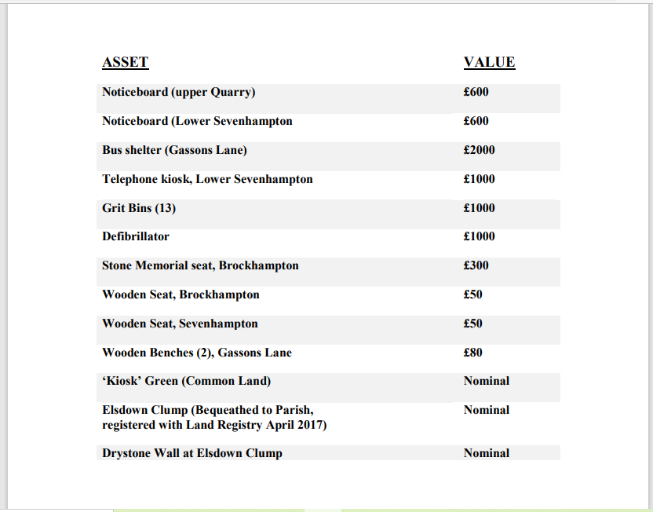

Telephone box at Brockhampton value - £1
Defibrillator at Sevenhampton value new £2550 – should this be added – discussion

